Introduction to STP
Why Do We Need STP?
Unlike IP packets at Layer 3 (which have a Time-To-Live / TTL field that eventually expires), Layer 2 Ethernet frames have no TTL. If a loop exists between switches, a broadcast frame (like an ARP request) will circulate infinitely. This causes three massive problems:
- Broadcast Storms: Switches endlessly forward broadcasts to each other, consuming all available bandwidth.
- MAC Database Instability: The switch constantly receives the same source MAC address on different ports, causing the MAC address table to thrash.
- Multiple Frame Transmission: End devices receive multiple copies of the same frame, confusing applications.

What is STP?
- STP- Spanning Tree Protocol an Open Standard Protocol
- Used to prevent layer 2 switching loop
- IEEE 802.1D standard

Bridge(Switch)
Bridge ID(BID)
Root Bridge)
Bridge protocol data unit (BPDU)

Bridge (Switch)
- In the context of Spanning Tree Protocol, the terms "Bridge" and "Switch" are used interchangeably.
- Historically, a bridge was a device with only two ports used to connect two network segments. Modern switches are technically "multi-port bridges."
- Because the IEEE 802.1D standard was written when bridges were the standard hardware, all official STP terminology (Root Bridge, Bridge ID, BPDU) uses the word "Bridge."

Bridge ID (BID)
- This is the unique "name tag" or identifier assigned to every switch participating in the STP process.
- Bridge Priority (4 bits):The default is 32768. It can only be configured in increments of 4096 (0, 4096, 8192, 12288, etc.).
- Extended System ID (12 bits): This is simply the VLAN number added to the priority. if you leave a switch at the default priority of 32768, running show spanning-tree for VLAN 1 will show a priority of 32769 (32768 + VLAN 1). For VLAN 10, it will be 32778.
- MAC Address (48 bits): The switch's base hardware address. If all switches have the same Priority, the lowest MAC address breaks the tie.
Method of Lower the Bridge ID
- The Command: Switch(config)# spanning-tree vlan 1 root primary
It typically drops the priority to 24576. If another switch already has a priority of 24576, this command will automatically drop the priority to 4096 less than the current root.
- The Backup Command: Switch(config)# spanning-tree vlan 1 root secondary (This sets the priority to 28672, ensuring it becomes the backup root if the primary fails).
Second method
- The Command: Switch(config)# spanning-tree vlan 1 priority 4096
It hardcodes the priority to exactly 4096 (resulting in a BID priority of 4097 for VLAN 1).
- You can set the priority to 0 using spanning-tree vlan 1 priority 0. This is the lowest possible priority, guaranteeing this switch will be the Root Bridge unless another switch with a lower MAC address is also set to 0.

Root Bridge
- The undisputed "King" of the Layer 2 topology. It acts as the center of the spanning tree universe.
- It is elected automatically because it holds the lowest Bridge ID (Priority + MAC Address) in the network.
- All other switches map their shortest, most efficient paths back to this specific switch.
- A true Root Bridge will never have any ports in a Blocking state; all of its active ports are Forwarding.

Bridge Protocol Data Unit (BPDU)
- The multicast communication frames that switches use to talk to each other about the spanning tree topology.
- They are sent out every 2 seconds by default.
- BPDUs contain crucial election data, including: the sender's Bridge ID, the Bridge ID of the switch they currently believe is the Root, and the cumulative Path Cost to reach that Root.
- If a switch stops receiving BPDUs on a port, it assumes a topology change or failure has occurred and recalculates the tree.
Designated Port (DP)
- A port role assigned on a per-segment (per-cable) basis. For every physical wire connecting two switches, exactly one side must be the Designated Port.
- It is the port that has the lowest root path cost to forward traffic from that specific network segment toward the Root Bridge.
- All active ports on the Root Bridge itself are Designated Ports.
- Designated Ports are always in a Forwarding state. (The side of the cable that loses the DP election becomes the blocked/alternate port)
Root Port (RP)
- A port role assigned only on Non-Root Bridges.
- Every non-root switch must elect exactly one Root Port.
- It is the single port on the switch that has the lowest cumulative "Path Cost" to reach the Root Bridge (the fastest route home).
- Root Ports are always in a Forwarding state.

Blocked
1.Lowest Cost to the Root Bridge (Root Path Cost)
- Each switch calculates the total cost to reach the Root Bridge.
- The switch/port with the lower total path cost wins and becomes the Designated Port (forwarding). The other side gets blocked.

2.Lowest Sender Bridge ID (BID)
- If paths have the exact same cost, STP looks at the Bridge ID (Priority + MAC address) of the switches on both ends of the link.
- The port connected to the switch with the lower (better) BID wins the forwarding role.
3.Lowest Sender Port Priority
- If it's still a tie (usually happens if two ports on the same switch connect to another single switch via redundant cables), STP checks the port priority advertised by the sender.
- The lower port priority wins

Switch(config-if)# spanning-tree vlan 1 port-priority 64
4.Lowest Sender Port ID (Port Number)
- As a final tie-breaker, STP looks at the physical port number/ID of the sending switch.
- The lowest physical port number wins the forwarding role, and the opposing port gets blocked

Spanning-Tree Path Cost Reference (Cisco)
Link Speed | Classic Short Mode Cost (16-bit) | Modern Long Mode Cost (32-bit)
10 Mbps | 100 | 2,000,000
100 Mbps (FastEthernet) | 19 | 200,000
1 Gbps (Gigabit) | 4 | 20,000
10 Gbps (10-Gigabit) | 2 | 2,000
40 Gbps / 100 Gbps | 1 | 500 / 200

1. How Path Cost is Calculated
When the Root Bridge sends out a BPDU, the cost inside that message starts at 0. As that BPDU travels downstream through the network, every receiving switch adds the cost of its receiving port to the total.
- Example: If a BPDU enters a FastEthernet port, the switch adds 19 to the total. If that switch forwards the BPDU to another switch, the next switch adds the cost of its receiving port, and so on. This creates the Cumulative Root Path Cost.
2. The Two Elections Where Path Cost is Used
The switch uses this cumulative cost to make two critical decisions:
A. Electing the Root Port (RP)
Every non-root switch looks at all the BPDUs it receives on all its active ports. It calculates the cumulative cost for every possible path back to the Root Bridge.
- The Rule: The single port that has the lowest total path cost to the Root Bridge is crowned the Root Port.
- Why it matters: This ensures traffic doesn't take a slow 10 Mbps route if a faster 1 Gbps route is available.
B. Electing the Designated Port (DP) on a Link
For every physical cable connecting two switches, only one side is allowed to forward traffic toward the Root Bridge. The switches on both ends of the cable compare their total Root Path Cost.
- The Rule: The switch that advertises the lowest Root Path Cost wins the election and makes its port the Designated Port (Forwarding). The loser must block its port (Alternate/Discarding).

Switch# configure terminal
Switch(config)# spanning-tree pathcost method long
Switch# configure terminal
Switch(config)# spanning-tree pathcost method short

State of Spanning tree protocol
There are five different states of STP. These are as follows:
1. Blocking State:
- It is a non-designated port.
- It does not take part in the forwarding of frames.
- Switch ports are kept blocked for 20 seconds. After that, they change to the listening state.
2. Listening State:
- It is the first state of the Spanning Tree Protocol after the blocking state.
- The STP decides whether to use the port in frame forwarding or not.
- The ports stay in the listening state for 15 seconds and then move on to the next state.
3. Learning State:
- This state helps prepare STP to participate in the frame-forwarding state.
- The STP discards frames received on the port during this state.
- It receives BPDUs.
- It learns the addresses.
- The learning state lasts for 15 seconds.
4. Forwarding State:
- The ports forward the frames received to the other ports in this state.
- It receives BPDUs in this state.
- It also learns the addresses.
- The ports remain in the forwarding state until any change occurs.

5. Disabled State:
- When an administrator commands the port to be disabled, the port enters the disabled state.
- It then discards the frames received on the port.
- It stops learning the LAN addresses.
- It does not receive BPDUs.

State of Spanning tree protocol
Each interface on a bridge using spanning tree exists in one of these states:
•Blocking—The interface does not participate in frame forwarding. (port down state)
•Listening—The first transitional state after the blocking state, in which the spanning tree determines that the interface should participate in frame forwarding.(Listening for BPDUS)
•Learning—The interface prepares to participate in frame forwarding. (Bpdu learn the network Topology)
•Forwarding—The interface forwards frames.(Forward data traffic DP and RP)
•Disabled—The interface is not participating in spanning tree because there is a port shutdown, there is no link on the port, or no spanning-tree instance is running on the port.

An interface moves through these states:
•From initialization to blocking
•From blocking to listening or to disabled
•From listening to learning or to disabled
•From learning to forwarding or to disabled
•From forwarding to disabled

State | Purpose | MAC Learning? | Forwarding Data? | Time Spent
Blocking | Receives BPDUs, drops data frames. | No | No | 20 seconds (Max Age)
Listening | Sends/Receives BPDUs to participate in elections. | No | No | 15 seconds
Learning | Populates the MAC address table silently. | Yes | No | 15 seconds
Forwarding | Normal operation. | Yes | Yes | N/A

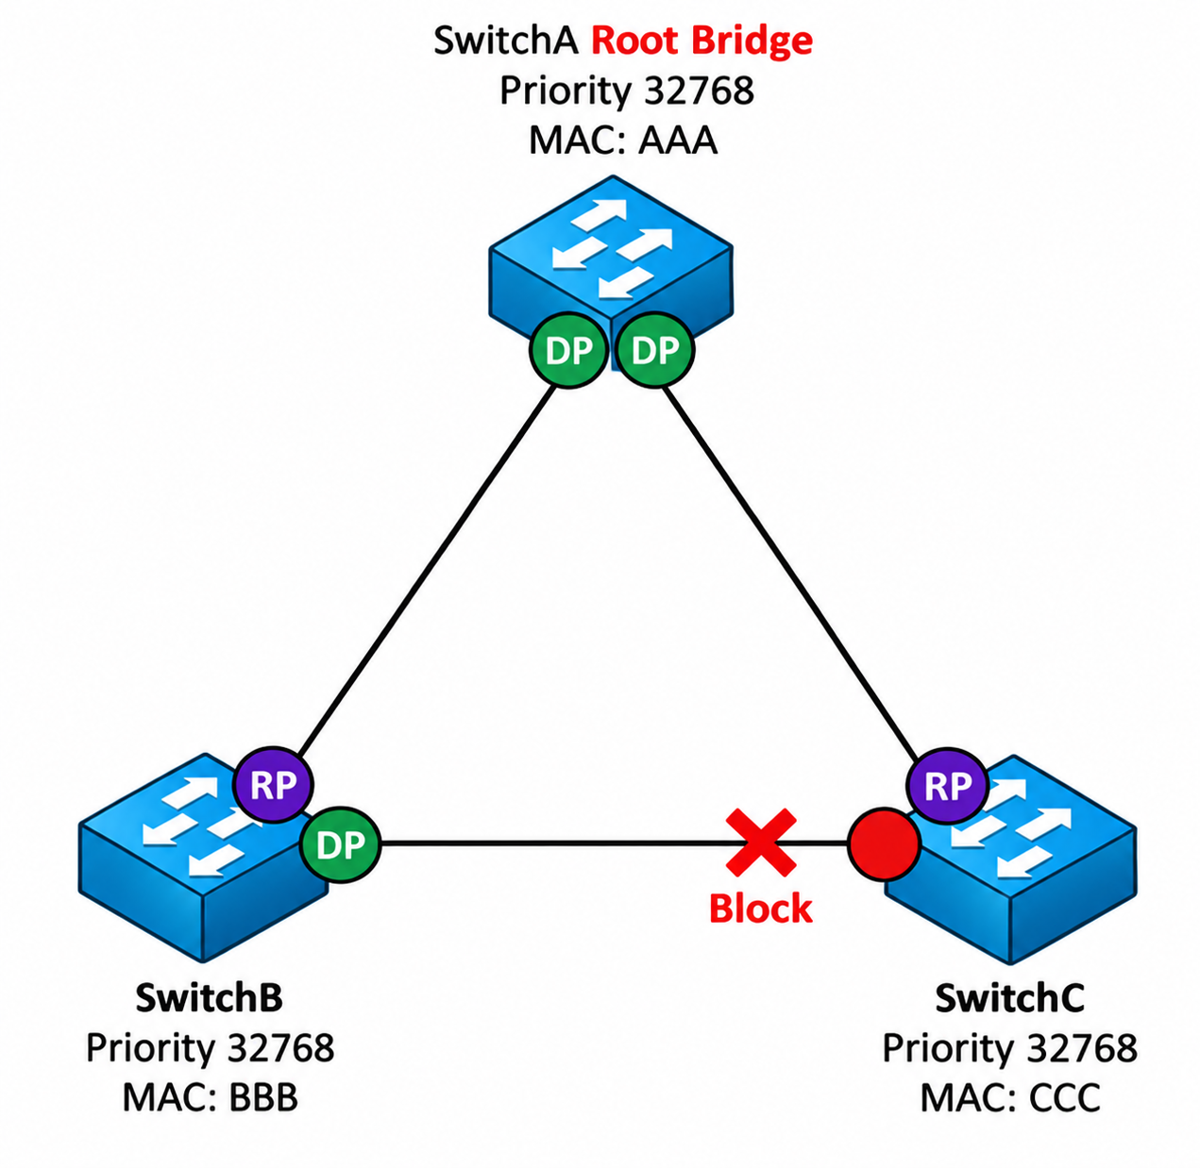

Protocol | Standard | Number of Trees | Convergence Time | CPU/Memory Usage
STP | IEEE 802.1D | One for all VLANs | Slow (50s) | Low
PVST+ | Cisco | One per VLAN | Slow (50s) | High
RSTP | IEEE 802.1w | One for all VLANs | Fast (ms) | Low
Rapid PVST+ | Cisco | One per VLAN | Fast (ms) | Very High
MSTP | IEEE 802.1s | One per Group of VLANs | Fast (ms) | Medium

Rapid PVST+ (Rapid Per VLAN Spanning Tree)

Rapid Per-VLAN Spanning Tree Plus (Rapid PVST+) is Cisco's proprietary spanning tree mode that serves as the default on most modern Catalyst switches. It takes the fast convergence of the IEEE 802.1w (RSTP) standard and combines it with the independent, per-VLAN architecture of Cisco's original PVST+.
- Lightning-Fast Convergence (The "Rapid" part): Instead of waiting 50 seconds for traditional timers to expire, it uses active BPDU negotiation (the Proposal and Agreement handshake) to transition ports from a discarding state directly to forwarding in milliseconds.
- Traffic Load Balancing (The "PVST+" part): Because it calculates an entirely independent spanning tree for every single VLAN, you can engineer Switch A to be the Root Bridge for VLAN 10, and Switch B to be the Root Bridge for VLAN 20.

Traditional STP (802.1D) | Rapid PVST+ (802.1w) | MAC Learning? | Forwarding Data?
Disabled | Discarding | No | No
Blocking | Discarding | No | No
Listening | Discarding | No | No
Learning | Learning | Yes | No
Forwarding | Forwarding | Yes | Yes

- Discarding – The port drops all incoming frames and doesn’t learn MAC addresses. This state combines the old 802.1D Disabled, Blocking, and Listening states since none of them allowed forwarding. RSTP doesn’t need a separate Listening state because it can quickly move to the next state without waiting for BPDUs.
- Learning – The port still drops incoming frames but starts learning MAC addresses.
- Forwarding – The port forwards incoming frames based on the MAC addresses it has already learned and continues to learn.

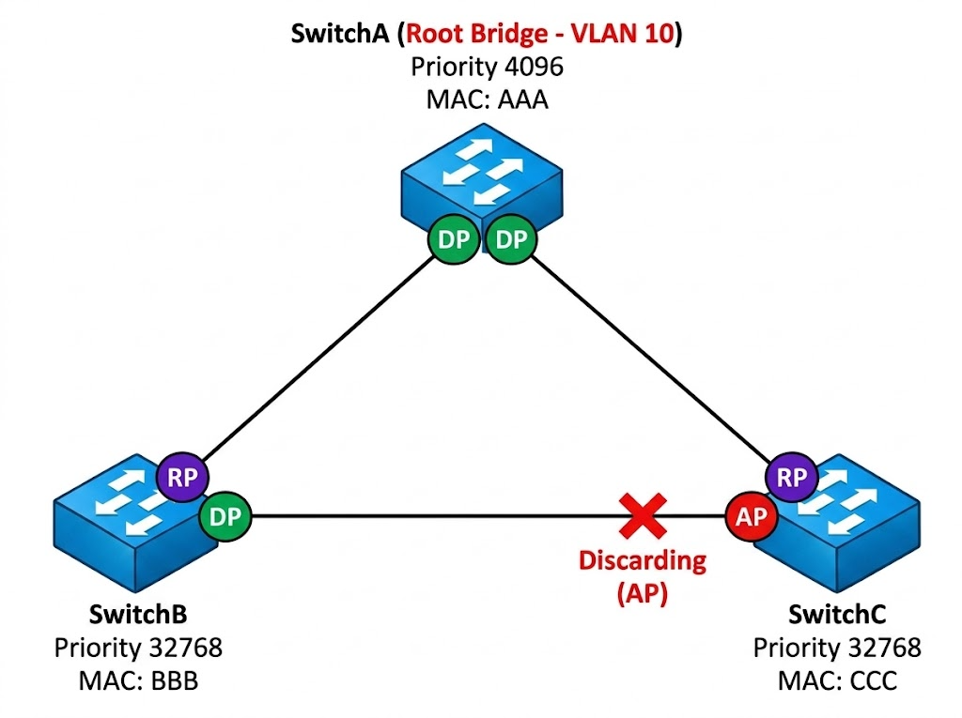

1. PortFast (Speeding up Edge Ports)
- The Problem: Standard STP takes 30 seconds (15s Listening, 15s Learning) before a port turns green and forwards data. When a PC or server boots up, this 30-second delay often causes DHCP requests to time out, leaving the device without an IP address.
- The Solution: Enabling PortFast tells the switch to completely bypass the Listening and Learning states. The port transitions directly from Blocking to Forwarding the instant a cable is connected.
- The Rule: PortFast must only be configured on ports connected to end devices (PCs, servers, printers). If you connect a switch to a PortFast port, it can create a temporary or permanent broadcast storm.

For Edge Ports (Facing PCs/Servers)
Apply PortFast and BPDU Guard directly on the access interfaces:

Switch(config)# interface FastEthernet 0/1
Switch(config-if)# spanning-tree portfast
Switch(config-if)# spanning-tree bpduguard enable

2. BPDU Guard (Protecting the Edge)
- The Problem: Because PortFast bypasses normal STP safety checks, a user plugging a rogue switch into a wall jack can instantly bridge two ports together, causing a network-crashing loop.
- The Solution: BPDU Guard is an active security feature. If a switch port configured with BPDU Guard receives a BPDU (a spanning tree message, which only comes from other switches), it immediately shuts the port down into an err-disabled state. The port will not forward any traffic until an administrator intervenes.
- The Rule: Always enable BPDU Guard on any port where PortFast is enabled.

3. Root Guard (Protecting the Core)
- The Problem: You have manually configured your powerful Core switch to be the Root Bridge. However, if an employee plugs in a cheap switch at their desk that happens to have a priority of 0, the entire network will recalculate the spanning tree, forcing all core traffic to flow through that cheap desk switch.
- The Solution: Root Guard enforces the Root Bridge placement. You configure Root Guard on the downstream ports of your primary switches. If that port suddenly receives a "superior" BPDU (one claiming to be a better Root Bridge), Root Guard blocks the port, putting it in a root-inconsistent state. It drops the BPDUs and prevents the rogue switch from taking over.
- The Rule: Apply this on ports facing away from your intended Root Bridge (downstream toward the access layer).

Apply Root Guard to downstream ports to prevent lower-level switches from taking over: For Core/Distribution Ports (Facing other Switches)
Switch(config)# interface GigabitEthernet 0/1
Switch(config-if)# spanning-tree guard root
4. Loop Guard (Protecting against Hardware Failure)
- The Problem: An Alternate port stays in a Blocking state because it constantly receives BPDUs from a neighboring switch. If a fiber optic cable gets damaged and can only transmit but not receive (a unidirectional link failure), the port stops hearing BPDUs. Standard STP assumes the neighbor is dead and incorrectly transitions the blocked port to a Forwarding state, creating a massive loop.
- The Solution: Loop Guard prevents this. If a port that was receiving BPDUs suddenly stops receiving them, Loop Guard intervenes. Instead of letting the port turn green, it forces the port into a loop-inconsistent (blocked) state until BPDUs resume.
- The Rule: Apply this on non-designated ports (Root ports and Alternate ports) that point toward other switches.
- Where to use it: On non-designated (blocked/root) ports across your core and distribution switches. Do not use it on ports where PortFast is turned on.

Apply Loop Guard to uplink ports (Root/Alternate ports) to protect against unidirectional link failures: For Core/Distribution Ports (Facing other Switches)

Switch(config)# interface GigabitEthernet 0/2
Switch(config-if)# spanning-tree guard loop

